PGCIL
Control Center Monitoring
Solution Document
i2v systems pvt. ltd |
Software Technology Parks of India, 3rd Floor, Plot No 30, Electronic city, Sector 18, Gurugram-122015, Haryana, India

2025

i2V Solution for PGCIL- Gurugram
1 About i2V 2
2 Objective and Scope of Work: 3
2.1 Scope Of Work 3
2.2 Objective 3
3 i2V Solution Component 3
3.1.1 Video Management Software: 3
3.1.2 Video Analytics Software (Time-lapse Video): 3
4 Architectural Diagram 4
5 Solution Description: 4
5.1 Video Management Software 7
5.1.1 Configuration Client: 7
5.1.2 Live view 9
5.1.3 Playback 12
6 Server Hardware & Storage Sizing 13
6.1 Server Hardware Sizing 13
6.2 Storage Calculation 13
6.3 Remarks: 14
7 Dependencies and Assumptions 14

VERSION CONTROL
Module | Version | Release Date | Author
Solution Design Document | 1.0 | 22-Jan-2025 | Amit Sharma

About i2V

i2V is a renowned Surveillance Software Technology Company focusing on Design, Development of Intelligent Video and Traffic Surveillance Solutions. We Specialize in Development of Proactive Video and Traffic Surveillance Products with aim of providing high Quality Software Engineering Solutions to Clients. We are an established player and rapidly growing Indian Organization (Under the Make in India Campaign) in Video and Traffic Surveillance with End-to-End Unified Video Surveillance Products Portfolio.

I2V’s Software Offering for the Video Surveillance Industry is as Follows:

- Integrated Command & Control System (ICCC)
- Video Management System (VMS)
- AI-Video Analytics System (VAS)
- Automatic traffic counting and classification (ATCC)
- Intelligent Traffic Management & Enforcement System (ITMS/ ITES)
- Facial Recognition System (FRS)
- Central Monitoring System (CMS)
- Video Summarization/Video Synopsis

i2V provide with best-in-Class End-to-End Video Surveillance Solutions with 24/7 support in India (Gurgaon) & UAE (Abu Dhabi) and have been doing business in more than 20 countries. With the robust and reliable products, i2V is approved in various government organizations including Railways, IGL, IOCL, BHEL, GAIL, HPCL, RDSO, MCC-UAE and various state PWDs.

The Certifications that i2V Holds are as Follows:

- i2V is ONVIF Profile G, M, S, T & Q Compliant
- RDSO Compliant & Approved
- ISO 9001:2015 Certified Organization
- ISO 14001:2015 Certified Organization
- ISO 27001:2013 Certified Organization
- ISO 45001:2018 Certified Organization
- ARAI Certified Speed Test
- STQC Certified

Objective and Scope of Work:

Scope Of Work
The project aims to automate and integrate security systems across the under-construction location of PFCIL in INDIA. The primary goals are to enhance security, optimize manpower, and improve operational efficiency by transitioning from standalone systems to an integrated security framework.

Objective
To establish a centralized monitoring system for CCTV cameras deployed across multiple under-construction sites. This system will enable real-time surveillance, centralized data storage, and the creation of time-lapse video analytics for one camera at each site. Additionally, this combined data can be transformed into actionable intelligence and disseminated to the appropriate PGCIL authority.

i2V Solution Component

Video Management Software:
VMS software is used to add and manage the cameras installed in SCDCL directly through ONVIF or SDK/API provided by manufacturer.
Video management system provide a platform which is designed for viewing, recording and replaying acquired video as part of overall project solution. It is used to view live and recorded video data from all CCTV cameras by selecting the cameras from the tree or by selecting the cameras from the map.
Continuous monitoring for disaster management support.
Attain faster turnaround time for municipal services through improved situational awareness.
Monitoring of suspicious people, vehicles, objects etc. with respect to protecting life and property and maintaining law and order in the construction sites.
Give citizens a sense of security and act as an aid to investigation, and help in deterring, detecting and thus dealing with criminal activities
Prevent vandalism and prevent damage to common property, monuments, and buildings.

Video Analytics Software (Time-lapse Video):
Video Analytics is a software analyse the live video in real-time to detect, identify, and track incidences and suspicious activity in the construction sites. Video Analytics software will identify and capture events on real time basis. It is used for eliminate need of human observation of video on a 24x7 basis.

Architectural Diagram
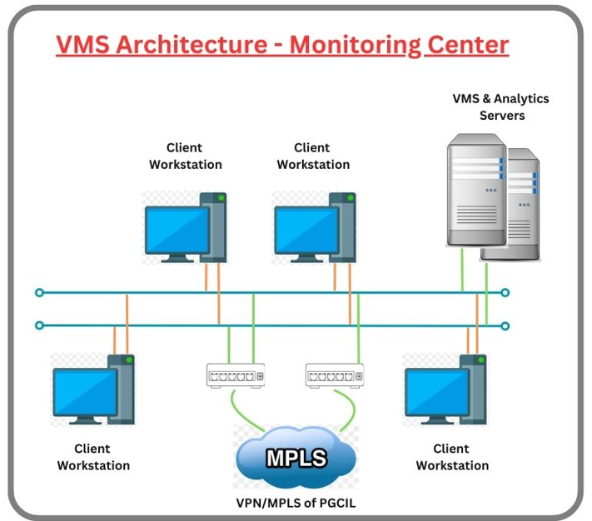

Solution Description:
- The complete system at Control Centre with VMS system (CCTV Surveillance System), AI based Video Analytics etc.

- The system would be useful in monitoring events like functions, demonstrations, Security Operations flow etc. and to improve the efficiency and effectiveness by introducing CCTV Surveillance and Management System.

Data Centre:
- In On-premises model, the Data Center will house the application and storage servers in the required secured environment.

- All the infrastructure for Video Management System, Video Analytics System and other components shall be hosted on the Premise Data Centre (DC) premises of the Control Centre.

Video Management Software:

- Video management system will provide a platform which will be designed for viewing and monitoring acquired video as part of overall project solution. This platform will be based on the Internet Protocol (IP) open platform concept.
- The project will have a total of approx. 200 surveillance cameras across various locations of PGCIL under construction sites pan INDIA.
- These cameras will work on 24 X 7 basis and transmit quality video feeds to the centralized data centre and would capture the video feeds of cameras.
- The cameras shall record all footage locally and have circular recording feature based on First-In-First-Out (FIFO). In the event of failure of connectivity and after the connectivity is restored, these recordings shall be automatically merged with the server recordings such that no manual intervention is required to transfer the locally stored recordings to server.
- Video Management Software will support proposed cameras live streaming, recording, network management, storage management, alarm management, user management, playback and backup for the viewing centre.
- The Software support H.264/H.265 or better, MPEG-4 and MJPEG compression formats for all IP cameras connected to the system.
- All camera settings (such as frame rate, bit rate, etc.) shall be configurable remotely through the VMS.
- Video feeds of approx. 200 cameras would be store for 180 days online/real-time on primary storage.
- For incidents that are critical/flagged by the PGCIL authority, the video of the relevant portion from all relevant cameras shall be stored/archived separately for investigation purposes and PGCIL authority can decide when this video feed can be deleted.
- The video recording will be over-written by the FIFO based rule configured in the VMS and Central Storage automatically after the pre-defined days.
- Artificial Intelligence based Video Analytics through various cameras at the central server with continuous learning capabilities.
- The analytic software will be capable of self-learning from false positives, false negatives and any other result sets. The recommended backend analytics servers process necessary GPUs and necessary AI capability to provide the mentioned basic and advance analytics feature.

Operator with proper right can do the following functionalities:
- Complete handling of VMS, Video Analytics through client system.
- The video surveillance data from various cameras deployed will be viewed and monitored at Viewing Centre.
- Operator at viewing centre can access and view video file in real time or demand basis for any camera from which alert has been generated or as and when the authorities intend to view the live video feed.
- Operator can View of cameras directly by clicking (On clicking of camera icon, the live video feed from camera will open).
- Provide search of recorded video. Advanced search should be possible based on various filters like alarm / event, area, camera, etc.
- Tracking route of specific person / object / vehicle for a specific period / location.
- Accessibility to advanced analytics on live & recorded footages.

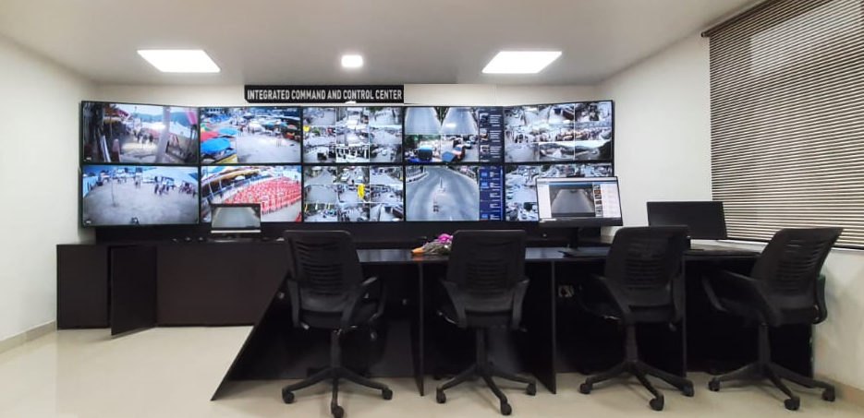

Video Management Software
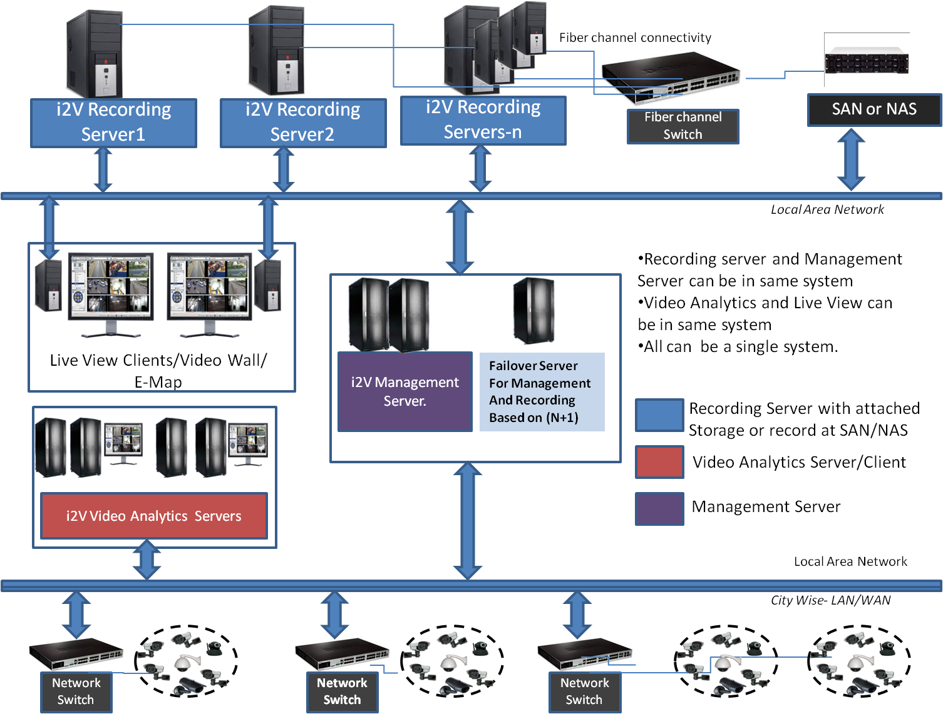
Following are the components of VMS:
- Video Management software
- Video recording Software
- Client Software

Configuration Client:

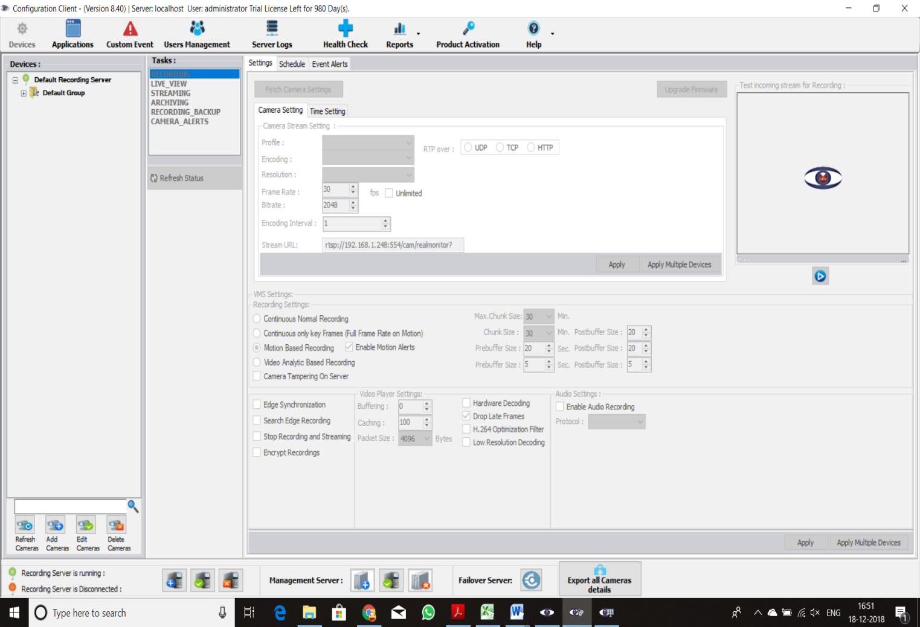

- Configuration client is the user Interface for configuring i2V server, cameras, NVR, encorder and other devices.
- Add and manage the Cameras/NVR installed in construction sites directly through ONVIF or SDK/API provided by manufacturer .
- Add/delete/edit camera, encoder, server and other devices in hierarchical tree manner
- Multiple Recording Server support. Expandable to Unlimited number of cameras.
- Supports non-proprietary hardware and storage
- Supports video profiles H.265, H.264, MJPEG, MPEG4, and 10-25/30/60 fps. All Camera supported resolutions and frame rate
- Supports recording in NAS,SAN, DAS, iSCSI and local hard disk
- Device, server, events, alerts , alarms and schedules settings
- Edge Recording Synchronization: VMS Server and Camera sync recordings in case of network or other communication failure between camera and VMS
- Test Live view, recording and streaming properties of devices
- Storage settings for add, edit, delete of storage drives
- Automatically set Date/Time by using NTP
- Support for Remote and Local Configuration setting
- Remote Camera configuration & Recording Server Configuration
- User Manuals and Technical Manuals available
- Generate logs & reports in Graphical & Tabular form and export in pdf , excel or more format
- Search Camera and view device(s) based on standard criteria like Camera ID/ Name, Location, Group, etc.
- System and network communication based health check
- Integration with 3rd party systems through their SDK/API.
- Support secure communication betwwen servers and clients.
- Dual Recording feature is available.
- Support Native Redundancy/Failover. Failover is not dependent on any 3rd party application and database.
- Automatic Data Replication between Main and Failover server.
- The VMS dashboard shall receive all alerts at any point of time triggered from devices and view the real-time feed on demand basis.

Live view

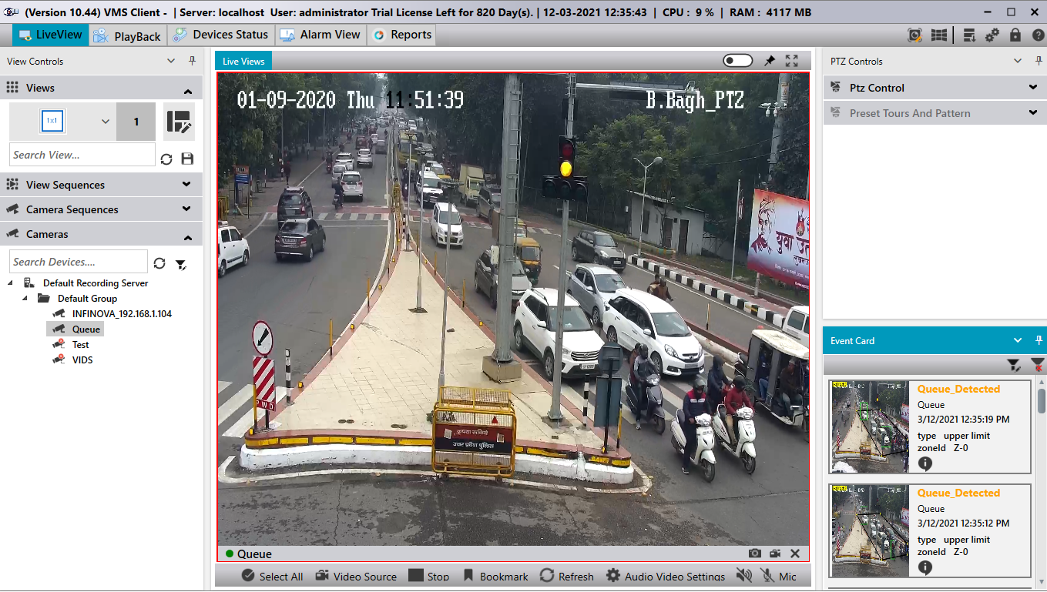

Live View Client:
- Real Time monitoring of any camera by clicking a specific camera.
- Simultaneously viewing of 50+ cameras in Live View at secondary Stream.
- Multiple users can be login simultaneously.
- 1x1, 2x2, 3x3, 4x4 and custom matrix view can be select by changing the grid dimension for viewing multiple cameras at a time.
- Camera sequencing feature for playing multiple views/cameras in regular time interval.
- Digital zoom Live View both on Fixed and PTZ camera.
- Video Popup/Blink & Sound Alarms in Live View.
- Bookmark of any portion of video
- Dual Streaming and Automatic Switching from Low to High Quality on Full screen mode
- PTZ operation with pre-set, tour
- On screen PTZ control with Click and Zoom facility
- E-map client show icon blink and voice alert of the event. Should be able to take snapshots from Google Map if connected to internet. It should be possible to click on icon in a map to initiate PTZ camera pre-set, run PTZ pattern, view camera
- Web and Mobile surveillance available.

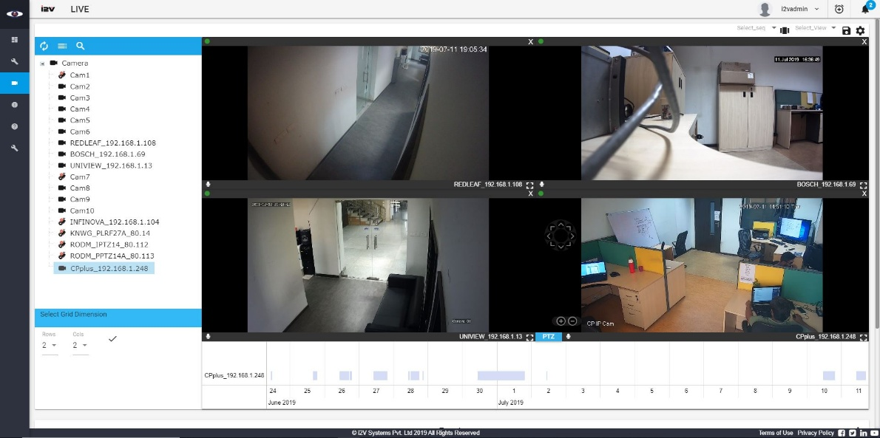
Scalability and Robustness:

- Scalable distributed client-server Architecture and user-friendly interface
- When the number of cameras increases, system will be remained scalable just by adding required no. of servers and storage
- Supports multiple Recording Servers per Management Server
- Scalable licensing model supporting unlimited cameras per server based on the available hardware configuration
- Supports addition of cameras on already licensed Servers
- Easy to Upgrade and Troubleshoot
- Service based Model: i2V software work on service-based model. The benefit of service-based model is that if any service crash/stop due to any reason then it will auto- restart within 1 minute. There are many services for different module like Management Service, Recording Service, Database Service, Watchdog service etc.

Management Server is the centre of complete enterprise management. It stores the complete system setting configuration in database on the management server computer. All Recordings Servers and Client Components will connect to the Management server for its operation via secured authentication.
Recording Service is the Standalone component handling complete recording and streaming by communicating with all the camera/Video devices. It stores the system configuration cameras, devices in the Recording Server database installed on the recording server.
  - The Recording System, once configured, run independently of the Video Management system and continues to operate in the event that the Management system is off-line.
  - Camera’s recording will be continuously store in the mapped storage if the Management Server goes offline.
  - Each Recording service is mapped with separate port.
  - In large installations, more than one Recording Server is often used on enterprise surveillance system.
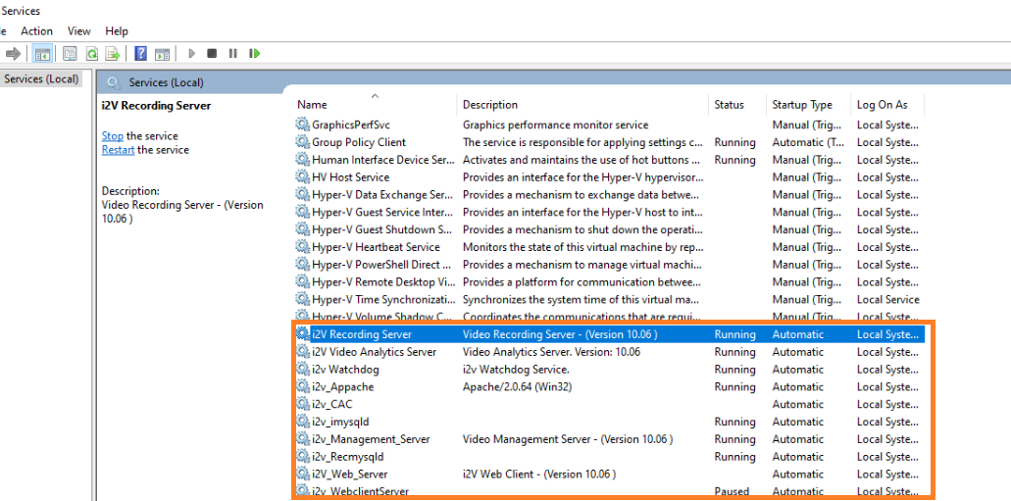
Database Service: The Management Service and Recording service has their independent database service for storing the device/cameras/server configurations and each service work on separate dedicated port.

Client Workstations:

The client software consists of Configuration Client, Live-View Client, Playback client, Video Analytics Client, E-Map/GIS/Google Map Client. The minimum client licenses included are as per requirement.

Playback

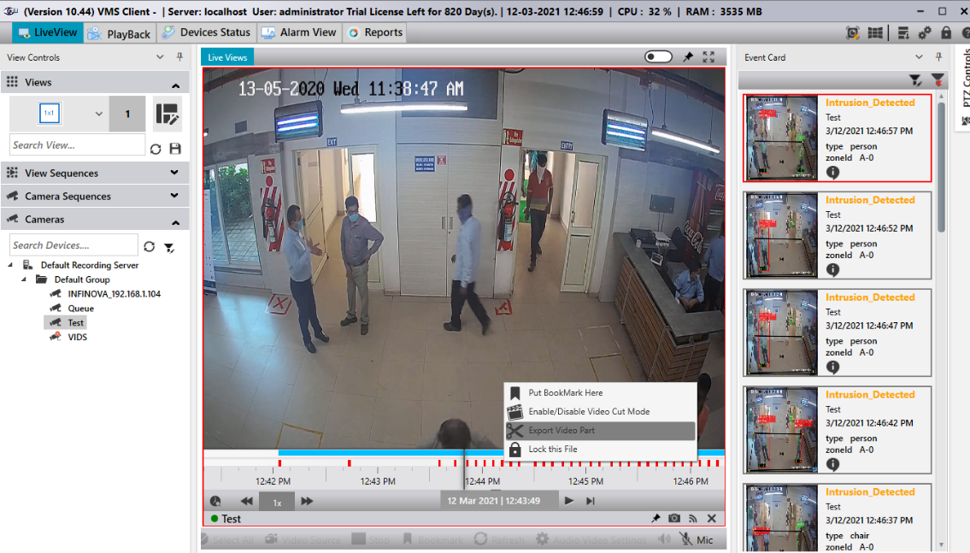

PlayBack Client:
- Intelligent Search based on Date/Time/Camera, Name, ID, Location for more than one camera simultaneously
- Quick Search of event-based recordings e.g., Motion Detection more than one camera simultaneously
- Play, Stop, Pause, Fast forward, Reverse playback, seek-bar, Slow, frame by frame Playing options, synchronization option, supports OSD from cameras
- Digital zoom on recording and Still images(snapshots)
- Video file export in avi, asf, mp4 at user defined locations to play files in Windows Media Player/VLC player/i2V Player and image in jpeg format
- Image enhancement on recorded videos
- Remote and Local access of Recorded Videos and Event snapshots
- Playback through Web and Android, iOS phones/Tablets
- Video Analytics Events snapshot-based search
- Timeline bar to show and replay recordings.
- Ability to make bookmark of any portion of video and view list of all bookmarks
- Video lock/Un-Lock features available
- Export Digitally Sign, 56/128/256-bit Encryption based tamperproof recordings at local and remote systems
- Support Forensic and Investigation mode.
Future Scope of Integration:-
I2V is an open plateform system where in any kind of 3rd party application can be inegrated with minimal charges with inegration scalability through API/SDK.

Server Hardware & Storage Sizing

Server Hardware Sizing
Hardware sizing for central monitoring and recording for 200 cameras at control room.
Application Module | GPU/Non-GPU /Workstation | No. of Servers | Server Configuration | RAM | GPU  Specifications | Internal Storage  (For OS & Application) | Operating System | Network Interface Card
I2V Central Video Management & Recoding Software | Non-GPU  Server | 1 Nos. | 2x Intel Xeon Processor (8Core/16Threads) ==Total 16Core  Base Clock Speed:  2.4 GHZ | 64 | - | 2x 480GB SSD  in RAID 1 configuration | Windows Server-2019/2022 | 4x1G Ethernet Port &  1x10G SFP+
PC/Client Workstation | Workstation | As per Req. | 1 x Intel® Core™ i9-10900 Processor  Base Clock Speed: 3.0GHz | 16 | 1x Nvidia T1000 (8GB) Graphics Card | 1x 500GB SSD | Windows 10/11-Professional  64 Bit Operating System | 1x1G Ethernet Port

Storage Calculation
Camera Type | Cameras | Recording  Resolution | Recording  Codec | FPS | Hours/  Day | Recording  Days | Bandwidth  Required per Camera  (Kbps) | Usable Storage (TB)  Without RAID | Disk Throughput  Random  (Mbps) | Storage Throughput  Random  (MBps) | Storage  IOPS
IP Camera | 200 | 1280x720 | H.265 | 25 | 24 | 180 | 1024 | 399 | 300 | 38 | 608

Remarks:
- Video management Software for 200 cameras with central recording at 1MP (1280x720) resolution, 25fps, 1024Kbps bandwidth, H.265 compression for 180 days.
- Client System for simultaneous viewing and monitoring of the following:
- Live viewing and Monitoring of 25 cameras at 720p, 25fps or 40cameras at 4CIF/D1, 15fps.
- Playback speed should be 1x.

Dependencies and Assumptions
Following assumptions are made for the above solution to work effectively:
- All cameras, hardware devices for must be connected with Control Center with proper bandwidth and networking.
- All hardware server, workstations and operating systems must be latest version from respective vendors.
- All Infrastructure Items, like Network Switch, Servers/LPU, Connection Cables, software other than Solution shall be provided by PGCIL Authority. i2V has no Role & is not bound for Providing any Infrastructure (ICT) Items for the Systems Completeness.
- Centralized Storage- considering total 200 cameras at 1280x720p @25fps, 1024Kbps & H.265 codec.
- Proposed storage must have sufficient IOPS or Data Write/Read speed.
- The Outgoing bandwidth at each camera location is dependent on the cameras being Live-Streamed & Playback of recording at the central location simultaneously.
- The Incoming bandwidth at central location is dependent on the total no. of cameras being monitored (Live or Playback) simultaneously from 1 or more locations.
- Storage calculations are given basis the assumed bit rate for the respective camera’s and for the duration. Partner shall get the exact camera-wise bitrate from the camera OEM. The bitrate assumptions can change by camera OEM, scene activity, frame-rate and compression.
- Objects, Person and Vehicle should be clearly visible in FRS camera field of view (FOV) and required the minimum 250-300 pixel per meter (ppm) for the FRS to run efficiently must be available.
- For integration purposes third party device or applications SDKs, database or any information that will be helpful for integration shall be made available to i2V by the MSI.
- This server storage sizing is only valid for the following six months. Please contact the i2V Presales Team for updated sizing once your validity period has expired.

